Shabbos Stories for
Parshas terumah 5774
Volume 5, Issue 23 1 Adar I 5774/ February 1, 2014
For a free subscription, please forward your request to keren18@juno.com

A Grateful Jeff Jacoby
We Are Blessed by an
Amazing Community.
By Jeff Jacoby

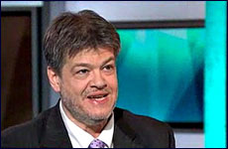
Jacob Jacoby

I've always liked Rudyard Kipling's 1895 poem "If—" , with its four stanzas of rugged, Victorian-era paternal advice. But it wasn't until this month, when my older son Caleb went missing for 80 hours and my wife and I were frantic with worry and fear, that I gained a real appreciation for the virtue with which Kipling's poem opens: "If you can keep your head when all about you / Are losing theirs…"

“I Had No Idea How to
Formulate a Plan of Action”
Never before has the quality of levelheadedness meant quite so much to me. As my mind lurched among nightmare scenarios and my gut churned with anxiety, it took an effort of will just to process what was happening. I had no idea how to formulate a plan of action going forward.
What are you supposed to do when your teenager has been gone for hours – six hours, 12 hours, 24 hours – and hasn't been seen or heard from? When you've called in the police and given them all the information you can think of? When you've checked your child's usual haunts and come up dry? When his friends, realizing that something is wrong, are beginning to sound the alarm on Facebook and Google Chat? And when the temperature outside is in the single digits – and falling?

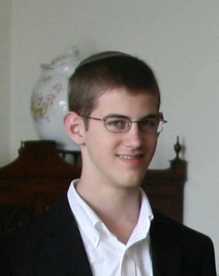
Caleb Jacoby

Left to our own devices, with no relevant training to draw upon, my wife and I would have been overwhelmed by panic and uncertainty. A natural-born crisis manager I am not. Fortunately there were others – steady, sensible, experienced – who were able to think clearly, set emotion aside, and impose some order on the turmoil.
There were three or four such people in particular who stepped forward to help without waiting to be asked. They organized themselves into a kind of war room operation and focused relentlessly, but calmly, on the immediate tasks at hand. How I admire their talent for keeping their heads when it was all I could do not to lose mine.

The Intensity of Interest in My Son’s
Disappearance was Extraordinary
After more than 25 years of working for newspapers, I figured I knew something about stories that grab public attention. But the intensity of interest in my son's disappearance was extraordinary. Of course some of that was due to the public following that comes with a regular byline in the Boston Globe. But I wasn't prepared for the way the news erupted, especially on social media, or how it radiated outward in wider and wider spheres of compassion and concern.
It astonished the police, too. "You have an amazing community here," the detectives working on the case told us more than once. Tips, queries, and offers of help surged into the Brookline police station. Maimonides, the Modern Orthodox Jewish day school where Caleb is an 11th-grader, coordinated a local search effort involving more than 200 volunteers. But offers of aid came pouring in from strangers in other states and countries, many of whom were prepared to drop everything and go anywhere they were needed to search for a teen they didn't know from a city many had never been to.
After 80 hours of anguish and fear, the relief we felt when our son was found was indescribable.

Defining an “Amazing Community”
That so Impressed the Detectives
The "amazing community" that so impressed the detectives wasn't just the community of Maimonides school students, administrators, and graduates, who poured heart and soul into finding Caleb. It wasn't just the broader Jewish community, so often riven by factions and disputes, that momentarily set those differences aside out of concern for a missing boy.
It was more – much more, as I came to understand while trying to make sense of tide of kindness, empathy, and worry that helped keep my family afloat during those agonizing days.
Like the interlocking circles of a Venn diagram, our "amazing community" is really many communities with one family common to all of them. We were embraced and helped and prayed for by people who are connected to us through our son's school or our local synagogue – as well as by others with different connections: residents of Brookline, my colleagues at the Boston Globe, companies my wife has worked for, readers (by no means all fans) of my column, fellow media people, our younger child's school, charities we support, causes we've been involved in, people who know Caleb's far-flung aunts, uncles, and grandparents.
And above and beyond them all, the "amazing community" of parents who have been through their own stresses and storms, and who know from experience that no family is immune to them.
During the worst ordeal of our lives, my family experienced the best that human beings are capable of. That was a blessing I'll never forget, or ever cease being grateful for.

Reprinted from last week’s email of Aish.com

Pope’s Vatican Hotel Kitchen
Goes Kosher for a Day:
Four-course lunch hosted by Pope Francis for dozen Argentine rabbis last week includes extensive, rabbinically supervised sterilizing of kitchen that on-site kosher cooking entails
By Nicole Winfield
Associated Press

For just one day, the kitchen of the Vatican hotel where Pope Francis lives went kosher.

Rabbi Jaakov Spizzichino oversaw the scrupulous cleaning of countertops, the boiling of utensils and the heating of the oven to render it fit for cooking under Jewish dietary laws.
The occasion? A four-course lunch Francis hosted for a dozen Argentine rabbis last week. It was another sign of his close friendship with Jews, despite some complaints in Israel that he's giving the Jewish state short-shrift on his upcoming trip to the Holy Land.

The Vatican Had Hosted Kosher Meals in
The Past for Visiting Jewish Delegations
The Vatican has hosted kosher meals for visiting Jewish delegations on several occasions, and Francis famously provided kosher takeout for one of his best friends, Rabbi Abraham Skorka, when Skorka stayed with him at the Vatican's Santa Marta hotel last year.
The January 16 luncheon in Santa Marta's dining room was a special occasion that warranted more – including the extensive, rabbinically supervised sterilizing of the hotel kitchen that on-site kosher cooking entails.

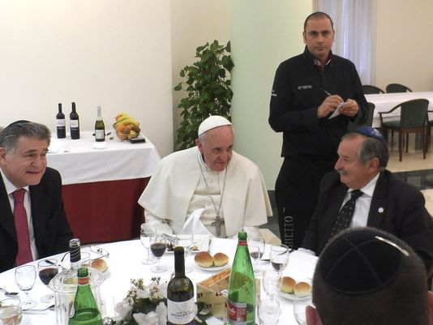

The Vatican pulled out all the stops as Francis hosted Skorka and about 15 other rabbis from Buenos Aires who came to Rome to visit their old friend. It turned to Ba'Ghetto, one of the best kosher restaurants on the other side of the Tiber River, to cater the affair.
"I decided to do it simple, because the pope is simple," said Amit Dabush, Ba'Ghetto's Israeli-born co-owner. "But the menu was full: He had to make a 'bella figura'" – a good impression – on his guests.
To do so, however, required on-site cooking, and that required Dabush and Spizzichino, a kosher inspector with Rome's chief rabbinate, to sterilize the small kitchen off the main dining room kitchen.

A Key Issue was the Oven
A key issue was the oven: According to Jewish dietary laws, an oven in a non-kosher kitchen must sit idle for 24 hours and be cleaned and turned on full blast for an hour to sterilize it, Spizzichino said. So on the morning of the luncheon, Dabush, some restaurant workers and Spizzichino set to work early: Scorching the oven and burners, scouring the kitchen countertops and covering them with aluminum foil to prevent the kosher food from being contaminated. They boiled and sterilized the big pots used for making pasta and set the tables with Ba'Ghetto's own plates and utensils.

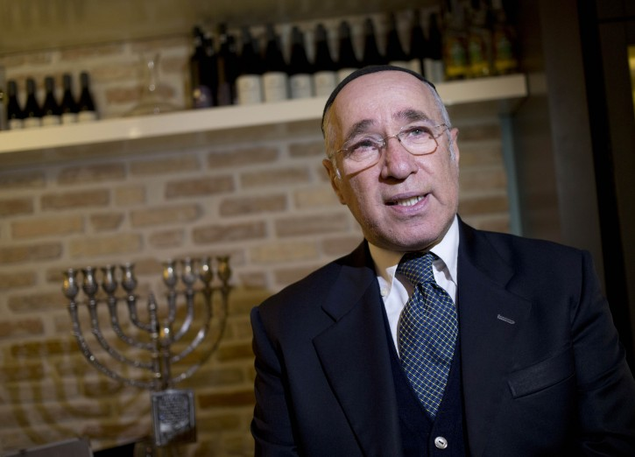
Rabbi Jaakov Spizzichino of Rome who oversaw the scrupulous
cleaning of the kitchen in the Pope’s Vatican Hotel

"It was a kitchen that they rarely used, so it was very clean," Spizzichino said.

The Menu was Heavily Fish-Based
The menu was heavily fish-based: Antipasti of deep-fried artichokes; baked sardines with endive and tangy, grilled zucchini. The pasta course featured two selections: Gnocchi with rocket, tomato and pine nuts, and hand-made trofie, or little twists of pasta with sea bass and tomatoes. The main course had two choices of fish: Baked turbot wrapped with vegetables or the house specialty, salt cod with tomatoes, pine nuts, grapes and potatoes.

A Beef Filet Option was Also Offered
Given the palates of his Argentine guests, Francis also offered beef filet with a Barolo wine reduction, which most chose, though he himself stuck to fish. Salad and roasted potatoes came next followed by desert: Two torts of chestnut and sour cherry, and the pope's favorite, pistachio mousse, made with a soy-based creamer imported from Israel to substitute the dairy that isn't allowed in a kosher meal featuring meat.

Reprinted from an Associated Press article published by hundreds of newspapers and radio station around the world.

Keeping it Kosher
On Master Chef
By Yoni Kempinski and Tova Dvorin

The Israeli version of Master Chef has an unlikely contestant this season: Rabbi Josh Steele, an immigrant from the UK who keeps all of Judaism's dietary laws.
Steele told Arutz Sheva that his participation in the reality show contest was a happy accident.
"I never applied for it," Steele explains. "My 14 year-old cousin wanted me to stay in Israel and not to move back to England, so she threw in an application form for me as a surprise."
"I've been in yeshiva for 5 years, I've made nothing but cholent for 5 years," Rabbi Steele marvels. He thought "there was no way" he could get onto the show, but tried to think of the qualifying round as "an experience."
Rabbi Steele identifies as an Orthodox Jew - and as an Orthodox Rabbi, being on a cooking show could be seen as a bold move. But the Rabbi explained that responses have been wildly positive.

A Kiddush Hashem with a Non-Religious Security Guard
"I had one security guard come up to me on the train and explain that he hated religion," he recounted, "because he thought he wouldn't able to be himself. Then he saw me on the show and said that he saw he could be religious and have fun in life."
Rabbi Steele described some of the unique challenges of participating in a cooking show in general. "There's lots of non-kosher food - but I don't cook non-kosher and I don't eat non-kosher," he proudly proclaimed. "I kasher all of my keilim [make all of his dishes and utensils kosher], all of the ingredients I use are kosher, I do everything pareve [suitable for meat or dairy meals]."

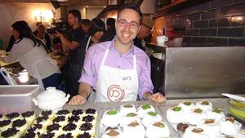
Rabbi Josh Steele

His Adherence to Jewish Law Only Brings
Out His Natural Creativity in Cooking
While some recipes can be difficult to reproduce, e.g. French dishes, Rabbi Steele explained that his adherence to Jewish law only brings out his natural creativity - and helps him convey a message about the role of food in Jewish life.
"If you cook amazing food, you'll say an amazing bracha [blessing] with amazing kavana [concentration] and be able to connect to hakadosh baruch hu [the Holy One, Blessed is He]," he enthused. "So that's what I'm trying to do, and hopefully I can succeed."

Reprinted from the January 24, 2014 email of Arutz Sheva.

A South African Tragedy
With a Happy Ending
By Rabbi Tuvia Bolton

Rabbi Ben-Tzion Grossman is a very devoted and talented Israeli Rabbi that has been bringing Israeli Jews back to their Jewish roots for tens of years.
Over thirty years ago two members of his congregation in Migdal HaEmek; a young married Israeli couple (let's call them Mr. and Mrs. Gold) went to visit relatives in Johannesburg South Africa and heard a frightening and sad story.
At that time the Jewish educational system in South Africa was far from adequate. There were only one or two basic Torah Academies and a few girls' elementary schools but no institutions of higher education or Chabad schools at all.
Well, it so happened that the town Shochet (ritual slaughterer), a truly G-d fearing orthodox Jew, had an eighteen year old daughter who after graduating High school, decided to enter University and major in Sociology.
She excelled in her studies and after completing her Master's degree with honors, began her doctoral thesis.

Opting to Do a Thesis on
Arab-Jewish Relations in Israel
Because apartheid was becoming an issue in those days she decided to do her thesis on Arab-Jewish relations in Israel and came to the conclusion that she would have to travel to Israel for a year in order to do the job properly (this was before the Intifada and Oslo Accords were made and Israel was relatively safe).
She bade her parents farewell, promised to be a good girl, write them once a week and embarked. Once in Israel she decided she would begin by studying the Arab side of the story and for that purpose made her temporary home in the Arab town of Juljilia not far from Haifa.
She hired a translator and worked feverishly, interviewing the populace by day and writing her dissertation into the wee hours of the night. But all this time, true to her Jewish roots, she continued to observe a Jewish way of life; Kosher food, Shabbat etc. and never considered otherwise …..

Until She Met George
Until she met George.
George was one of the citizens of Juljilia, but, unlike the other Arabs, he had been educated in Oxford and had a Masters in Sociology. Exactly her field. And he was more than glad to help. He was intelligent, kind, warm and handsome fellow, full of compliments and deep insights.
At first they just worked together, but after a while their relationship became less and less academic and as Sarah's attraction to him waxed, her feeling for Judaism waned.
The commandments that were once so comforting to her became dry rituals, and Shabbat instead of being a source of rest and spiritual renewal became a cold, empty bore; And so it was with everything else Jewish, including her Jewish identity.
She told her parents what was happening and they tried to dissuade her but their arguments and pleas bore no fruit. She had made up her mind; George was her friend, her companion, her soul-mate! It was so obvious, logical and right!
She and George got married.

Her Parents Naturally Were Devastated
Her parents were devastated. In fact her mother took it so to heart that it wasn't long afterward that she suffered a stroke while her father fell into a depression that made it almost impossible to continue working. And so it continued for years.
When Mrs. Gold heard this sad story she decided to pay Sarah's parents a visit, maybe there was some way she could help. After all the Lubavitcher Rebbe taught that every Jew is responsible for every other Jew. Indeed, for the entire world! She had to at least give it a try.
At first they didn't want to talk about it, her mother just left the room but finally her father began weeping and poured out his broken heart.
In those days Chabad-Lubavitch and the Rebbe were almost unknown in South Africa. In addition the Jews there were generally very cold to the Chassidic way and ridiculed the idea of relying on a Rebbe especially by long distance.

The Father was Finally Convinced to
Write a Letter to the Lubavitcher Rebbe
But finally she convinced him that his only hope was to write to the Lubavitcher Rebbe in New York, that he had nothing to lose and everything to gain. So with no other choice he wrote the Rebbe a letter briefly explaining the problem and asking for a blessing and advice.
A few weeks later the answer arrived. The Rebbe wrote:
"Wait for a time when they quarrel. I will pray for success and good news."
It made no sense. How could he wait for news from his daughter who lived in some remote Arab town in Israel thousands of miles away?! He hadn't spoken to her for years!
He told some of his friends about the Rebbe's answer and it became the joke of the town. People regarded the whole thing as a farce; the Rebbe had never met anyone mentioned in the letter. How could he possibly give advice?

Mrs. Gold Developed a Plan
But Mrs. Gold didn't take it so lightly. Inspired by the Rebbe's answer developed a plan. She convinced the girl's father to write down his daughter's phone number, the one she called him from last, and after she and her husband returned to Israel and she had some free time she went to the phone, said a prayer and a Psalm and dialed.
Someone answered. She asked "Is this Sarah?" and waited for a reply.
"Yes, this is Sarah. Who is this?"
It was a miracle!
The conversation was short Sarah only said yes and no but amazingly she didn't hang up.

An Offer to Call Whenever the Need Arises
It ended with Mrs. Gold saying, "Look, Sarah, here is my phone number. Write it down. Anytime you want, no matter when or for what reason, you can call me. My house is always open to you."
Sarah didn't say a word, just waited till Mrs. Gold finished speaking and hung up the phone.
Over a year passed and somehow Mrs. Gold completely forgot about Sarah until late one night, well after midnight, her phone rang.
It was Sarah calling from a public phone. She was in the city park in Haifa with her two children and eight month's pregnant with a third. She and her husband had quarreled and he beat her. She needed help.
Mrs. Gold immediately contacted Rabbi Grossman who told her to give his address to Sarah and tell her to take a taxi to his home immediately, at his expense. Then they would decide what to do.
She arrived, bruised, cold and hungry and the next morning, after a good meal and sleep she broke down and told them the truth.
After the first child was born George changed. Instead of the kind, warm person she married he became more and more possessive, violent and anti-Semitic. This wasn't the first time he beat her, although it was the most severe. And now she wanted out.
For many reasons they decided that the best solution was that she should temporarily return to George and make peace for a few weeks until after she gave birth to this third child. Then she should tell him that she wants to go for a rest with the children for a week or so and in this time they would engineer a getaway.
And it worked.
Today Sarah is far from her mistaken identity, happily married and living a real Jewish life thanks to a strange answer from the Rebbe.

Reprinted from last week’s email of Yeshiva Ohr Tmimim in Kfar Chabad, Israel.

A Moment with Rabbi Avigdor Miller, Z”tl

Preparing for a Date

QUESTION:
Are there any specific things a girl should do to be zoche to marry a true ben Torah?

ANSWER:
Yes! One is that when there is an appointment to meet one of the bnei Torah, she should make it her business to go first to the beauty parlor. That's a specific thing to do to marry a true ben Torah. It's a pity so many girls don't know that.
Another specific thing is, to brush your teeth from the age of six and on. So when you're going to meet that candidate and you'll flash a smile, it shouldn't be a row of crooked and decayed teeth. A lot of specific things a girl should do to marry a true ben Torah.
Of course she expected me to say what prayers should she add at the end of shemonei esrei. Certainly she should pray to Hakadosh Baruch Hu, but don't forget that she has to do certain things that Hakadosh Baruch Hu wants her to do, things that are simple and direct in addition to all the other things. I didn't answer that question fully, but a little bit is also good.

Reprint of Question #144

QUESTION:
Should a girl prepare for a date by making herself attractive, or should she think that the one that's destined to her from heaven will take her anyhow?

ANSWER:
Hakadosh Baruch Hu promised our forefathers to give them Eretz Canaan, He promised them Eretz Yisroel. And He didn't give it to them unless they did their best to get it. What did they have to do? First of all they had to cry out in Mitzrayim; they had to cry out from the bottom of their hearts. Various expressions: tze'oko, ne'oko, shav'uh, ze'oko - they cried out. Finally Hashem heard their outcries, and I'll help them, and also I remembered my covenant with Avrohom. All of a sudden absent-mindedly, He reminded Himself that there was a covenant, too.
The answer is, there could be a covenant, and it was some covenant, the bris bein habsorim! It's a covenant! But you have to activate the covenant. Hakadosh Baruch Hu wants you to work very hard that the promise should come true. And finally when He took them out of Mitzrayim, now they came to Eretz Canaan, seven years war! Seven years war!!! Why did they have to fight for, it was a promise? The answer is, Hashem promises you and if you'll win after all that effort, it's His promise, because a lot of people have tried more than seven years of war and they ended up in failure.
And so, here is a basherter, a beautiful and wealthy big lamdan, a young yeshiva man is waiting for you, and his name is written right next to yours on the invitation printed in heaven. It says kol soson v’kol simcha, on the heavenly invitation, and your name is there and his name is there. But you‘d better be energetic about it, otherwise it'll never be delivered to you. The postman will get mixed up on the way!
You say he's a frum fellow, he doesn't care about hair! He cares about hair. He's so innocent, he thinks you were born with the curls, he doesn't know that it takes three hours to make the curls. So get busy and spend the three hours.
The same is with everything else, Hakadosh Baruch Hu gives us promises, but we have to work very hard that the promise should come true.

Reprinted from this week’s email of “A Moment with Rabbi Avigdor Miller,” based on transcriptions of questions and answers to questions asked of Rabbi Miller at his famous Thursday night hashkafah lectures at his Flatbush shul from the 1970s until his petirah in 2001.

Syrian Jewish Community Puts
Down Roots on the Upper East Side
By Lindsay Armstrong

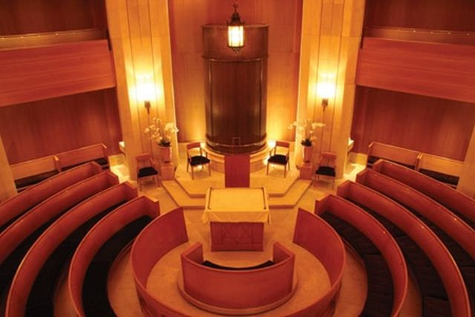
The Edmond J. Safra Synagogue in Manhattan

UPPER EAST SIDE — Prime Butcher and Baker on the Upper East Side stocks many classic European-Jewish treats including pastrami, kugel and rugelach. Nestled alongside these traditional favorites are dishes with less familiar names such as matbucha, lahmabajin and stuffed yebra: all staples of Syrian cuisine.
The shop’s mix of familiar and exotic offerings reflect a larger change in the Upper East Side Jewish community.

A Small But Thriving Community
Has Sprung Up in the Area
While the overall Jewish population of the neighborhood has declined in the past decade – from about 65,000 people in 2002 to about 57, 000 in 2011 — a small but thriving Syrian Jewish community has sprung up in the area.
The growth has been spurred in large part by the establishment of a Syrian synagogue, the Edmond J. Safra Congregation, in 2003. With the opening of the 65,000 square-foot Safra Community Center slated for later this year, the uptown Syrian community seems poised to expand.

An Alternative to the Suburbs
“The Upper East Side had become an alternative to the suburbs,” said Rabbi Elie Abadie, head of the Safra synagogue. “People can move here without sacrificing any of the community involvement or spiritual involvement because we have institutions now that were not here before.”
Abadie has noticed tremendous growth in the community during the past decade. When the synagogue hosted its first service early in 2003, just 35 people attended. A little more than ten years later, Abadie estimates that 350 people regularly attend services at the East 63rd Street location. The synagogue’s membership has grown to include 1500 families.
There are about 12,000 Syrian Jewish households in the New York metro area according to a 2011 demographic study by the United Jewish Agencies Federation. Half of them are located in Brooklyn, especially in the Syrian strongholds of Flatbush and Bensonhurst. For the first time, the study also noted the presence of a cluster of Syrian Jews on the Upper East Side, but it did not provide any numbers on the community.

Young Couples and Families
Account for Much of the Growth
Young couples and families account for much of the growth, according to both Abadie and the UJA Federation. They are drawn to Manhattan for the same reasons as many other young New Yorkers: financial opportunities and a cosmopolitan lifestyle.
“The new generation wants to be a part of American life,” Abadie said. “They want to be proud, engaged Jews who are also a part of the city and a part of the modern dialogue.”
David Mallach, director of the UJA Federation's Commission on Jewish People, said that economic changes within the larger Syrian community may also play a role in this geographic shift.
“The old family business model, particularly in textiles, has declined,” Mallach said. “The younger generation has gone more into finance and business. It’s becoming a more economically diverse community and Manhattan is attractive to them.”

Owns Many High-End
Restauratns in Manhattan
Joey Allaham, a member of the Safra synagogue, moved to Manhattan nine years ago with his young family. Allaham, 38, owns several high-end Kosher restaurants in Manhattan and said that the Upper East Side has many advantages over his former Brooklyn home.
“You wake up in the morning and you have the greatest city in the world at your feet,” he said. “You go five minutes and you have Central Park, the theater, great restaurants.”
His move has also been good for business. A few years ago, the restaurateur noticed something missing in his neighborhood.
“I told my wife, I have to do a Sephardic food shop here so that we don’t have to run back to Brooklyn all of the time,” he said.
That idea turned into Prime Butcher and Baker. Business, Allaham said, has been very good.
The growth of services that cater to the community, like Allahams’ shop, has in turn brought more Syrians to the Upper East Side.
In 2006, Rabbi Abadie realized that many members of his growing congregation were moving back to Brooklyn once their children reached school age. He proposed building a school to make it possible for families to stay in the neighborhood.
Five years later, the Sephardic Academy of Manhattan opened with an early childhood education program. The plan is to eventually grow the school to provide pre-K through 12th grade services.

The Safra Community Center
The Upper East Side Syrian community will also see its most ambitious initiative yet brought to fruition later this year. The Safra Community Center at East 82nd Street and Lexington Avenue will boast a swimming pool and fitness center, a two-level banquet hall and a kosher café. The building will also house a Sephardic synagogue to cater to all Jewish people who live on the northern edges of the Upper East Side.
The hope is that having access to such amenities will allow people in the community to put down Manhattan roots.
Rabbi Sion Setton heads the Sephardic Congregation Magen David in the West Village. Until recently, he served as the youth coordinator at Safra and said that the Syrian communities on the Upper East Side and in other parts of Manhattan have become less transient.

Many People Seem to be Here to Stay
“It started as temporary, but now people seem to be here to stay,” Setton said. “There’s a growing Sephardic and Syrian presence in the city and people are moving here to be a part of that.”
The pull of Brooklyn can remain strong, however, even for those who love their new neighborhood.
Leron Elkharrat moved to the Upper East Side three years ago shortly after she got married and has built a strong circle of friends there.
“Many of us are newlywed couples that like to stay in for Shabbat some weekends,” Elkharrat said. “Living just a few blocks away from each other, we have Shabbat meals together and holidays together. It’s great.”
But Elkharrat is not sure what the future will hold.
“I would love to stay on the Upper East Side forever, but I don't know what we will end up doing. Raising a family and buying or renting a bigger apartment in the city is significantly more expensive than it is in Brooklyn,” she said. “But you never know!”

Reprinted from last week’s email of the AJOP (Association of Jewish Outreach Professionals) Update. The article originally appeared in the January 13, 2014 edition of DNAinfo New York.

An Accidental Israeli: A Trip
To Manila Paves the Way Home
By Carl Hoffman

Congratulate me.
I have just reached an important milestone in life: five years in Israel. I realize, of course, that this short span of time pales before those reached by people who have lived in this country for decades – who built houses amidst sand dunes, who ventured out to establish communities in the middle of vast orange orchards, and who fondly remember their now bustling cities back when they were miniscule moshavim, lacking traffic lights or even paved roads.
My unique milestone draws its significance not from the amount of time I have spent here, but rather from the sheer irony of my being here at all. I hold the distinction of being perhaps the least likely human being on this planet to have made aliyah. Five years in Israel is no mean feat for a guy who spent most of his life swearing that he would never, ever, set foot here.

Bar Mitzvahed in a Conservative
Synagogue Near Boston
I was Bar Mitzvah’ed almost 40 years ago in a Conservative synagogue on the outskirts of Boston, where my famously non-religious parents piously attended services for an hour or two every Yom Kippur. That Bar Mitzvah, attended by my large family of Kennedy-style super-liberals, proved to be my last brush with Judaism, in any shape or form, for more than three decades.
I walked out of the synagogue and into the 1960′s. Following a rather colorful Flower Child adolescence, about which the less said the better, I went on to college – in New York’s Greenwich Village – where I majored in anthropology and minored in East Asian studies. My subsequent graduate school years saw me in Indonesia, doing my doctoral fieldwork on the island of Borneo, where the only Jewish face I saw in two years was my own reflection in the turbid, slow-moving water of jungle rivers and streams.

Living the Life of an “Expat”
American in the Phillipines
Those two years in Indonesia were followed by thirteen in the Philippines, where I lived with a hill tribe in a remote mountain village for three years, lived and worked among Indochinese boat people in a refugee camp for six years, and then hopped around the country’s 3,500 islands teaching and consulting for a year or two after that. I met, chased and eventually married a hard-working provincial social worker, had two beautiful children, and quickly learned to enjoy the life of an “expat” American in the lush Philippine countryside. Judaism was, at best, a distant and irrelevant memory.
Then, when I least expected it, life’s Great Referee flashed me a yellow card. An unexpected job offer with the Philippine government’s Department of Education brought us out of the boondocks and into Manila, where I soon heard faint but persistent rumors of the existence of a small but viable Jewish community. Intrigued by the image of Jews in the Philippines, I set out one Saturday to find them.
After I had wandered around Manila’s business district for more than an hour, a small, squat, gray building adorned with a large iron menorah and topped with a golden dome loomed sharply into view. Cleverly camouflaged amidst the gleaming office towers and five-star hotels, set behind a tall wrought-iron gate and protected by uniformed Filipino security guards, the Philippines’ one and only synagogue stood shockingly before me.

Discovered an Orthodox
Congregation Devoutly Praying
Passing the rather elaborate security check, I entered the amazing little building to find an Orthodox congregation of roughly 80 people, devoutly praying the morning service for Sabbath. Later, at the lavishly catered kiddush, a pale, bespectacled and very young man in a black velvet kippa introduced himself to me as the Rabbi (The Rabbi! I gawked. In the middle of Manila!) and asked if this was my first visit to the shul.

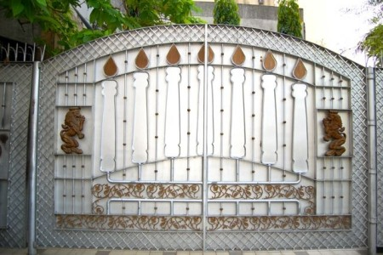

“It’s my first visit to any shul in more than thirty years,” I said to him.
He smiled, shook my hand, and said, “Welcome home.”
Now, those of you who misspent your 1950′s childhoods reading comic books will no doubt recall that Superman had a weekend getaway place at the North Pole, which he fondly referred to as his “Fortress of Solitude.” Hidden and buried amidst the windswept snow and ice, the Fortress was filled with a myriad number of souvenirs, trophies, mementos and assorted brick-a-brack gathered from years of fighting crime in Metropolis, safeguarding America, and patrolling the immediate galaxy.

Superman’s Special Connection
To the Planet Krypton
Still with me? Among Superman’s favorite tchochkes at the Fortress was the Bottled City of Kandor – an actual, living city from his home planet Krypton, shrunk, somehow, to miniature size and housed in a small climate-controlled glass jar, which Superman kept on a lovely walnut Queen Anne side-table at the end of an upstairs hall. When Superman felt that he needed to be with his fellow Kryptonians, speak a little Kryptonese, eat a bit of heimische Kryptonite food and just generally reconnect with his Krypton roots, he would enter the Bottled City.
Emerging from this sentimental journey a few hours later, a refreshed, recharged and remotivated Superman would leave the North Pole and fly back to Metropolis, back to his never-ending battle for truth, justice, and the American Way – and his somewhat complicated relationship with Lois Lane.
Well, the little synagogue in Manila – nestled amongst the towering office buildings and five-star hotels of the city’s business district – became my Bottled City of Kandor, a weekly haven from the stress of life and work, and a revitalizing return to my roots. I went every Saturday morning to surround myself with Jewish faces, recharge my mind with Jewish conversation, and stuff myself with Jewish food.

The Trouble is that Your Wife Gets Curious
But the trouble with having a bottled city, as Superman no doubt discovered after he finally broke down and married Lois Lane, is that sooner or later your wife wants to go into the bottle with you. After several weeks of wondering where I was sneaking off to every Saturday morning, my non-practicing Catholic Filipina wife decided to accompany me to shul.
You can imagine, of course, what happened next: as it has so many times before, in places scattered throughout the world, the synagogue cast its irresistible spell. My wife found a seat in the women’s section, and I spent the next couple of hours discreetly watching her watch Judaism as it unfolded before her. I watched as she opened a prayer book and slowly became engrossed in portions of the English translation.

Discovered Her Fondness for
Kugel and Chopped Herring
I saw her eyes widen as the ark was opened and a huge ornate Sephardi-style Torah, with gleaming polished silver crowns, was paraded around the sanctuary and taken up to the bimah. I caught her faint smile as the congregation began to sing. And later at the kiddush I noted, with little surprise, her evident fondness for kugel and chopped herring.
As we walked home I said, “Well, that’s what I’ve been doing every Saturday. No big deal, right?” To which she replied, “Next week, we’ll bring the kids.”
Bring them we did – the next week, and every week thereafter. It soon became apparent to me that we were well on our way down a long new road I had never expected to travel. Regular synagogue attendance, involvement in the Jewish community, the beginnings of Sabbath observance, some tentative stabs at keeping kosher, weekly study sessions with the Rabbi, Hebrew lessons for the children – a gaudy kaleidoscope of Judaism flashed around us at dizzying speed and soon enveloped us completely.
When, after a year or so of this, my wife announced that she wanted to formally convert and raise our children in an authentically Jewish environment, I knew that it was time to leave the Philippines and make aliyah to Israel. My relatives in the U.S. simply sighed, shrugged, and pronounced this as fresh evidence of the sort of bizarre behavior they have always expected of me.

Assisted by a Young First Secretary
At the Israeli Embassy in Manila
As no one from the Philippines had made aliyah since the end of World War II, a helpful young first secretary at the Israeli Embassy in Manila appointed himself as our sheliach, faxing Jerusalem almost daily with questions about how to do the paperwork. The Ambassador summoned us to his office, to satisfy himself that we were, as he put it, “for real.” A stamp for our immigrant visas had to be sent by diplomatic pouch from the Israeli Embassy in India, as no such stamp was to be found any farther east then New Delhi. After more a year of planning, processing and paperwork, we were on our way.
We arrived at Ben Gurion Airport, dazed but excited. In due course my wife was converted, the children studied and flourished in religious schools, and we slowly but inexorably became “Israelis.”
Life, I have learned, is something that goes on while you are planning something else. Or, as my grandmother used to say, “Man plans, God laughs.”

This story originally appeared in Lovetaps, by Carl Hoffman, iUniverse, Inc. (August 26, 2003).
Carl Hoffman, originally from the US, holds a Ph.D degree in Anthropology from the University of Pennsylvania, and has lived among headhunting groups in Borneo and a remote hill tribe in the Philippines. He has worked as a university lecturer in the United States, a research anthropologist in Indonesia, and as a Peace Corps volunteer in the Philippines; followed by a series of odd jobs with the US State Department Refugee Programs, the Philippine Department of Education, and the Japanese Embassy in Manila. He has lived in Israel since 1997 with his wife and two children. He is the author of two books: “Punan” (1986), an anthropological study of jungle tribes in Borneo, and “Lovetaps” (2003), a collection of short stories. Hoffman also teaches advanced courses in reading comprehension of academic writing for students in the social sciences at Israel’s Open University. You can reach him by email at drcarlhoffman@gmail.com

Reprinted from last week’s email of the AJOP (Association of Jewish Outreach Professionals) Update. The article was reprinted courtesy of Asian Jewish Life.

A Holocaust Survivor’s Struggle to Have Children
By David Bibi

Rabbi Fischel Schachter told over a story of a woman, a Holocaust survivor, who settled in America after the war and was married for twelve years without having children. One day she was sitting in a doctor's office on Madison Avenue in Manhattan, and the doctor, going over her charts, said to her, "Madame, please listen to me. I am saying this for your own benefit, give up. Medically speaking, there is nothing we can do so you can have children. When hair will grow from my palm that is when you will have a child."

Boarded the Madison Avenue Bus
The woman left and boarded the Madison Avenue bus. During the ride, she contemplated her life. She recalled the horrors she experienced as a young girl in Poland, when the family had a trap door beneath the dining room table and they would go and hide under the floor when the Nazis approached.
She volunteered to be the one to close the door, put the carpet over it and then hide on top of a piece of furniture. She would sit there, all curled up, and listen in terror as the Nazis searched the house, smashing furniture as they went from room to room. Time and time again, the family was saved. But finally, the Nazis noticed a soft spot on the floor, and they discovered the trap door. This young girl watched as the Nazis dragged her family away. She was the only one who survived the war.
Once she got to America, she desperately wanted to begin a family. And now, after twelve long years, her hopes were shattered.
She said to herself, "I have no reason to get off this bus." And so she stayed on the bus, sitting there the rest of the day. Finally, the driver informed her that he was driving the bus to the garage for the night, and she needed to disembark.

“I Have Nothing to Live For”
"I have nothing to live for," she muttered.
"Listen, lady," the driver said, "I've had a hard day. I don't know what your problem is, but you're not going to solve it by staying on this bus."
She got off the bus and said, "Master of the world, You were with me all along. You saved my life countless times. You brought me here. You let me start my life over, and so it is in Your hands. I have no right to give up. The bus driver is absolutely right, You didn't save my life for me to live on the Madison Avenue bus. Please tell me what to do. I won't give up. I will continue serving You no matter what."
A year later, she had a child.
That child grew up, got married, and has his own grandchildren. By the time this woman passed away, she had enough great-grandchildren to make that doctor's hair stand up.
Rabbi Fischel Schachter added that he heard this story firsthand from the woman herself , whom he knew quite well. She was his mother.

Reprinted from last week’s email of Shabbat Shalom from Cyberspace.

